|  |  |
| --- | --- |
| **Project Title** | **What if China employ lean hog future? Evidence from the United States** |
| **Name** | **SU Yulu** |
| **Student ID** | **A0182009L** |
| Unit: hours | |
| - Data collection | 6 |
| - Literature review | 16 |
| - Programming and Statistics Testing | 38 |
| - Market Study | 18 |
| - Report Writing | 30 |
| **Total workload** | **108** |
|  |  |
| **Original contribution** | - **Provide a thorough** **Introduction the hog industry in the United States and China,**  - **Prove the current stage of China hog industry in comparison with the United States industry,**  - **Study the different characteristics of CME lean hog futures,**  **- Check the model’s accuracy on predication of CME lean hog futures,**  **- Give advice to China market based upon the United States market.** |

**What if China employ lean hog future? Evidence from the United States**

**Abstracts**

Lean hog future is created by CME in 1980s’ and it is a hedging instrument designed to assist pork industry to stabilize the pork price. China market suffered pork price increasing in 2018. The China government is researching to launch lean hog future to stabilize the pork industry. This article examines the development stage of China pork industry in comparison with the United States pork market. By analyzing historical data of CME lean hog future and other futures, this article helps researchers to understand the characteristics of lean hog futures and gives suggestions to China pork industry participants. The characteristics include seasonality, volatility clustering, correlation with other futures and global impacts. The article also demonstrates the predication in accordance with these features and the predication accuracy.

**Keywords**

Lean Hog Future, China, the United States, Corn Future, Live Cattle Future, South Korea, Seasonal AutoRegressive Integrated Moving Average (SARIMA), Generalized AutoRegressive Conditional Heteroskedasticity (GARCH), Vector AutoRegressive (VAR), predication

1. **Introduction**

In 2018, the pork price surged in China due to African swine fever. The first case was found in August 3, 2018. In the following months, millions of pigs were killed because of the disease and hundreds of millions CNY loss was incurred. As a necessity on the table of Chinese people, pork has always affected the CPI index. After transmission, it is directly related to the expectations of inflation and the direction of macro-control policies. After the crazy increase of the price, people were talking more to establish a pork-related future market to prevent the price inflation in the future.

China, as the country with the largest number of slaughter pigs in the world, has a market size of over one trillion CNY, accounting for about 57.46% of the world's total slaughter. The upstream and downstream industrial chain of pigs involves feed, breeding, veterinary medicine, slaughter, food and other fields. There are tens of thousands of directly connected enterprises and more than 100 million employees. After the listing of hog futures, it will play an important role in improving China's hog price formation mechanism and assisting the industry to stabilize business profits. First, hog futures can provide a fair forward price for the industry. Breeding enterprises can adjust the scale of breeding by referring to the forward price to avoid cyclical sharp price fluctuations caused by blindly increasing or decreasing the number of stocks. Second, hog futures will provide risk management tools for the hog industry.

The United States is the second biggest country for hog breeding and consumption. The development of hog large-scale breeding and hog futures was earlier than China for many years. The pig industry chain mainly includes three links: production, slaughter, processing and consumption. From 1960s, USA had already launched the frozen pork belly future contract and the hog futures. After years of development, the market in USA is mature and provides lots of lessons for China market. After analyzing American Lean hog futures, we can learn more information about the futures and will avoid detour in our practices in futures market and related risk management.

Price volatility of agricultural commodity has been grown in past few years and have substantial implications on market. (Wang, Fausti and Qasmi, 2012). In this environment, Isengildina, Irwin and Good (2004) indicate agricultural forecasts are becoming more and more important in decision making and that the accurate predication can help the market significantly. It is crucial for investors to comprehend the features of pork industry and lean hog future. Since China has no lean hog future yet, we find that the CME lean hog future is a unique dataset for lean hog future research. In this article, we will analyze what features of CME lean hog future has. The features of CME lean hog future include seasonality, volatility clustering, correlation with other futures and global interactions. After testing the features, we will use the features to predicate the future’s price and check the accuracy. In China, the lean hog future debates are mainly about the difficulties of launching the lean hog future. In this article, we will pay attention to the features and predictions of lean hog futures, which is brand new area by now. This article provides more information to market managers and participants to understand the nature of lean hog future.

In this paper, we will first introduce the development history of pig industry in USA and compare the China pork industry development with USA pork industry. In the second and third part, we will test the seasonal ARIMA model and volatility of lean hog future. These two features are tested by historical data of lean hog future. The fourth part focuses on the relationship between lean hog, corn and live cattle. The corn is the feeder of pigs and live cattle is substitution of pigs. They can affect pork price. The fifth part, we discussed the relationship between lean hog futures in different countries and figure out whether they have correlation. The fourth and fifth parts involve the interaction of different futures. In the final part, we will summarize the article and pay attention to the difficulties China will meet.

1. **Pig industry development in USA**

In America, hog’s industry has three specialized enterprises: Farrow-to-Finish, Farrow-to-Feeder, and Feeder-to-Finish operations. The first enterprise is to produce piglet, raise piglets to mature pigs and then slaughter mature pigs. The second company is feed pigs and sell them to farrow. The third corporate buys the feeder pigs and then slaughter pigs. The first type of company controls the upstream and downstream. The second and third enterprises are responsible for different stages of pig cultivations and slaughter. They cooperate and streamline the pig’s production.

The pig industry usually takes around 10 months to grow a pig to slaughter weight from birth, with 4 months for breeding and gestation and 6 months to raise the litter to market weight.The first stage is farrow-to-wean stage, it will take almost 3 weeks to wean piglets. In this stage, the little pigs will grow to about 10 pounds from birth. The second stage is wean-to-feeder stage. Pigs in the second stage are fed to approximate 40 pounds. However, since the injected protein varies, the pigs grows rate also change accordingly and the growing time in second stage is uncertain. The third stage is feeder-to-finish. In this phase, pigs will be fed until they reach around 280 pounds for slaughting. The Farrow-to-finish company will control all three stages. The Farrow-to-Feeder corporate is responsible for stage 1 and stage 2. The Feeder-to-Finish enterprise only focus on stage 3.

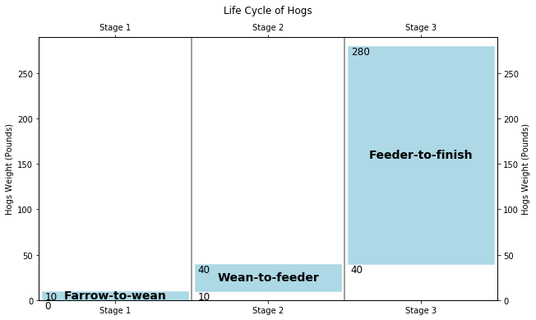

Figure 2-1. Life Cycle of Hogs

William D Mcbride and Nigel Key (2013) mentioned that The United States company in pig industry has structural changes in increasing size and specialization of hog’s operation during 1992-2009. The structural changes had three pronounced characteristics. The first feature is that the quantity of Farrow-to-Finish companies decreased substantially during 1992-2004 and the specialized companies in Farrow-to-Feeder and Feeder-to-Finish increased. However, the increased quantity in Farrow-to-Feeder and Feeder-to-Finish companies is less than the quantity of decreased Farrow-to-Finish companies. The reason is that the scale of hog corporation became much bigger than previous, but the quantity of companies declined. The companies which specialized in Farrow-to-Wean and Wean-to-Feeder increased a lot and became the majority. The Farrow-to-Finish companies became minority. This trend is obvious during 1992 to 2004. However, the transformation from full coverage companies to specialized companies slowed down from 2004 to 2009. The Farrow-to-Finish companies decreased slightly, and the companies focused on Phase 1 and Phase 2 increased little. The market share of two types of companies stayed equilibrium. The second feature is that the production contracts are more frequently used from 1992. Companies which operated under contract were major in the market and were more likely to be the companies specialized in Phase 1 and Phase 2. On the contrary, the omnipotent companies are minority. However, the share of hogs manufactured under contract grew slowly from 2004 to 2009. The third feature is that the companies in pig industry increase their efficacy and productivity substantially because of large scale of production and technological innovation from 1992 to 2004. However, the technology contributions to companies’ production increase started becoming slow from 2004 to 2009. The three features manifested that the 2004 is the watershed in American pork industry. From 1992 to 2004, the pork industry rapidly developed to modernization. From 2004 to 2009, the developed pork industry innovated little.

As China economy took off after reform and opening, livestock production in China started to become modern and professional in the 1990s (Fang et al., 2000). In China thirteen five-year plan, China government guide the agricultural modernization transformation from resource-intensive to technology-intensive, and realize an intensive, efficient, safe and sustainable modern agricultural development mode. In hog industry, the traditional Farrow-to-Finish companies narrow their working scopes to smaller segmentations and pay more attentions to technology. More and more professional and modern Farrow-to-Feeder and Feeder-to-Finish companies are established. The plan promotes the coordinated development of the three major industries of planting, breeding and slaughtering, highlights the importance of “modern seed industry, standardized breeding, quality and safety, and disease prevention and control”, established five goals of “improving quality, increasing efficiency, stabilizing supply, ensuring safety, and promoting ecology”. In 13 five-year plan China hog industry will transform producing methods, improve producing quality and efficiency, optimize the manufacture layout and green development, integrate the pork manufacture industry, stimulate consumption and complete policy support. The specific target is that by 2020, the pork output will increase steadily based on the end of the "Twelfth Five-Year Plan", the scale of large-scale farming will reach 52. According to the 13 five-year plan, China’s hog industry is now in an era of rapid modernization and is more similar to the USA hog industry from 1992 to 2004.

United States founded its hogs related derivatives in 1980s. During 1992 – 2004, the derivatives markets were developed well. China hog industry is going through the United States hog industry development during 1992 – 2004. The article will focus on the performance of lean hog futures from 1992 to 2004. Some crucial features of the lean hog futures are listed in Table 1-1 (Source: Bloomberg).

Table 2-1. Contract Specifications

|  |  |
| --- | --- |
| **Item** | **Contract Specifications** |
| Exchange Symbol | LH1 |
| Exchange | Chicago Mercantile Exchange (CME) |
| Underlying | LHGO Comdty |
| Tick size | 0.025 |
| Contract Size | 40,000 lbs |
| Value of 1.0 pt | USD 400 |
| Tick value | USD 10 |

The Lean hog futures’ daily data are collected from Bloomberg from 1992 to 2004. The Figure 1-2 shows the futures’ daily movement, moving average volatility and daily return. The first subplot in Figure 1-2 is about daily close price. The daily close price is not stationary and has no obvious trend. The second subplot is annualized volatility. The volatility has strong clustering effect according to the image. The third subplot is return of lean hog future. The future return is calculated by log return and is seemingly stationary. The following article will test the return of future in Seasonal ARIMA and GARCH model for more details.

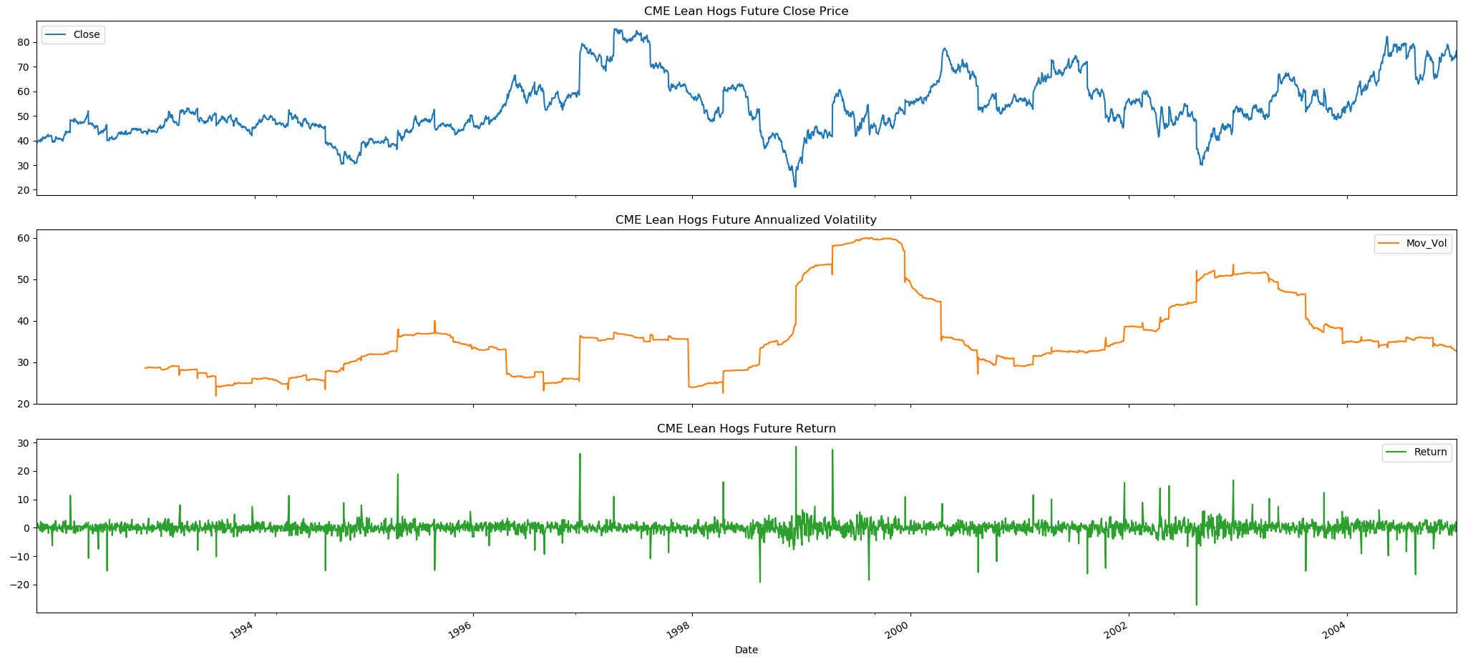

Figure 2-2. CME Lean Hog Future close price, annualized volatility and return

The daily log return is resampled to monthly data and multiple 100. The monthly data summary information is also shown as below. The skewness is between -0.5 and 0.5, the data are symmetrical. The kurtosis is positive so that the distribution has heavy tails. The distribution image shows that the distribution is symmetrical and has heavy tail.

Table 2-2. Lean hog future statistics summary

|  |  |
| --- | --- |
| **Summary** | **Details** |
| Count | 155 |
| Mean | 0.401569 |
| Std | 8.187216 |
| Min | -24.911243 |
| 25% | -4.334213 |
| 50% | 0.432202 |
| 75% | 5.000366 |
| Max | 34.446780 |
| Skewness | 0.073770 |
| Kurtosis | 1.864762 |

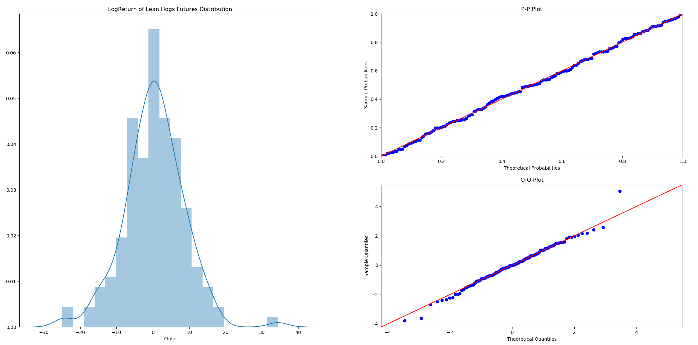

Figure 2-3. Log return of lean hog future histogram, P-P and Q-Q plot

In order to confirm the lean hogs futures log return is stationary, several unit root tests are conducted as below. VR tests was performed firstly to test whether the time series is random walk or stationery. P-value is smaller than 0.05 and the null hypothesis that the series is a pure random walk is rejected. The tests of stationarity with ADF, KPSS, DFGLS, Philips-Perron and ZA statistics shows that the time series is stationary.

Table 2-3. Unit root test of 100 times log return of lean hog future

|  |  |  |  |  |  |  |
| --- | --- | --- | --- | --- | --- | --- |
|  | **Variance-Ratio Test** | **Augmented Dickey-Fuller** | **KPSS** | **Dickey-Fuller GLS** | **Phillips-Perron** | **Zivot-Andrews** |
| **Test Statistic** | -2.210 | -3.150 | 0.043 | -2.665 | -9.049 | -3.937 |
| **p-value** | 0.027 | 0.023 | 0.916 | 0.008 | 0.000 | 0.390 |
| **Lags used** | 12 | 10 | 1 | 10 | 14 | 10 |
| **1%** |  | -3.48 | 0.74 | -2.70 | -3.47 | -5.28 |
| **5%** |  | -2.88 | 0.46 | -2.08 | -2.88 | -4.81 |
| **10%** |  | -2.58 | 0.35 | -1.77 | -2.58 | -4.57 |

1. **Seasonality ARIMA test for lean hog future**

In part 2, we understand that pigs have life cycle. It takes about 10 months for a pig to grow from birth to finish. The supply of pigs is subject to the life cycle of pigs. The price of pigs will also show the seasonality effect. In China, when the spring festive approaching, people will increase the consumption of meat including pork. The demand side also fluctuate based upon season.

According to US meat consumption data, chicken and beef consumption account for a relatively large proportion, and pork consumption ranks third in meat consumption. Its consumption has maintained a steady and small increase in recent years. According to USDA Economic Research Service, hogs slaughter counts in commercial shows periodical changes in the below figure 2-1. In the part, we will test the seasonal effect of the lean hog future.

Figure 3-1. Commercial Hogs Slaughter Counts (1000 heads) [1]

3.1 Seasonal ARIMA Introduction

ARIMA is an abbreviation name of AutoRegressive Integrated Moving Average. The first differencing ARIMA formula can be written as

Where is the time series and is . The right side of formula includes lagged values of and lagged errors. In ARIMA model, p is the order of the autoregressive, d is the degree of differencing, q is order of the moving average part. In our model, we use the first differencing ARIMA model, namely ARIMA (p, 1, q).

A seasonal ARIMA model includes extra seasonal components in models. The formula is written as follows:

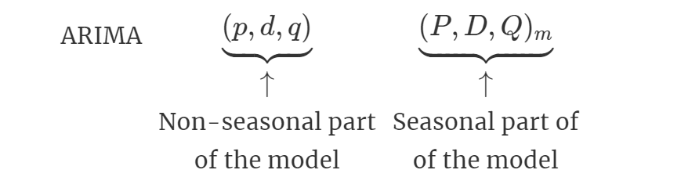

where . The seasonal components of the model are similar to the non-seasonal parts of the model. The seasonal component has backshift tests for seasonal period. For example, an model (without a constant) is for annual data ( ), the formula is

Seasonality in time series implies that the time series can repeat over a certain period. Like China market, the pork consumption arrives peak before the spring festival. The pork consumption has seasonality effect and it is predicated that the consumption will reach peak again before the next spring festival.

3.2 Seasonal ARIMA Test

The test data is monthly log return of lean hog future, which is stationary shown in the part 1. The below figure 2-2 is generated by sm.tsa.seasonal_decompose function. This image decomposes the lean hog future return time-series into three distinct components: trend, seasonality, and noise. Analyzing the chart, the time-series has seasonality pattern is obviously observed. There is a random trend over the years.

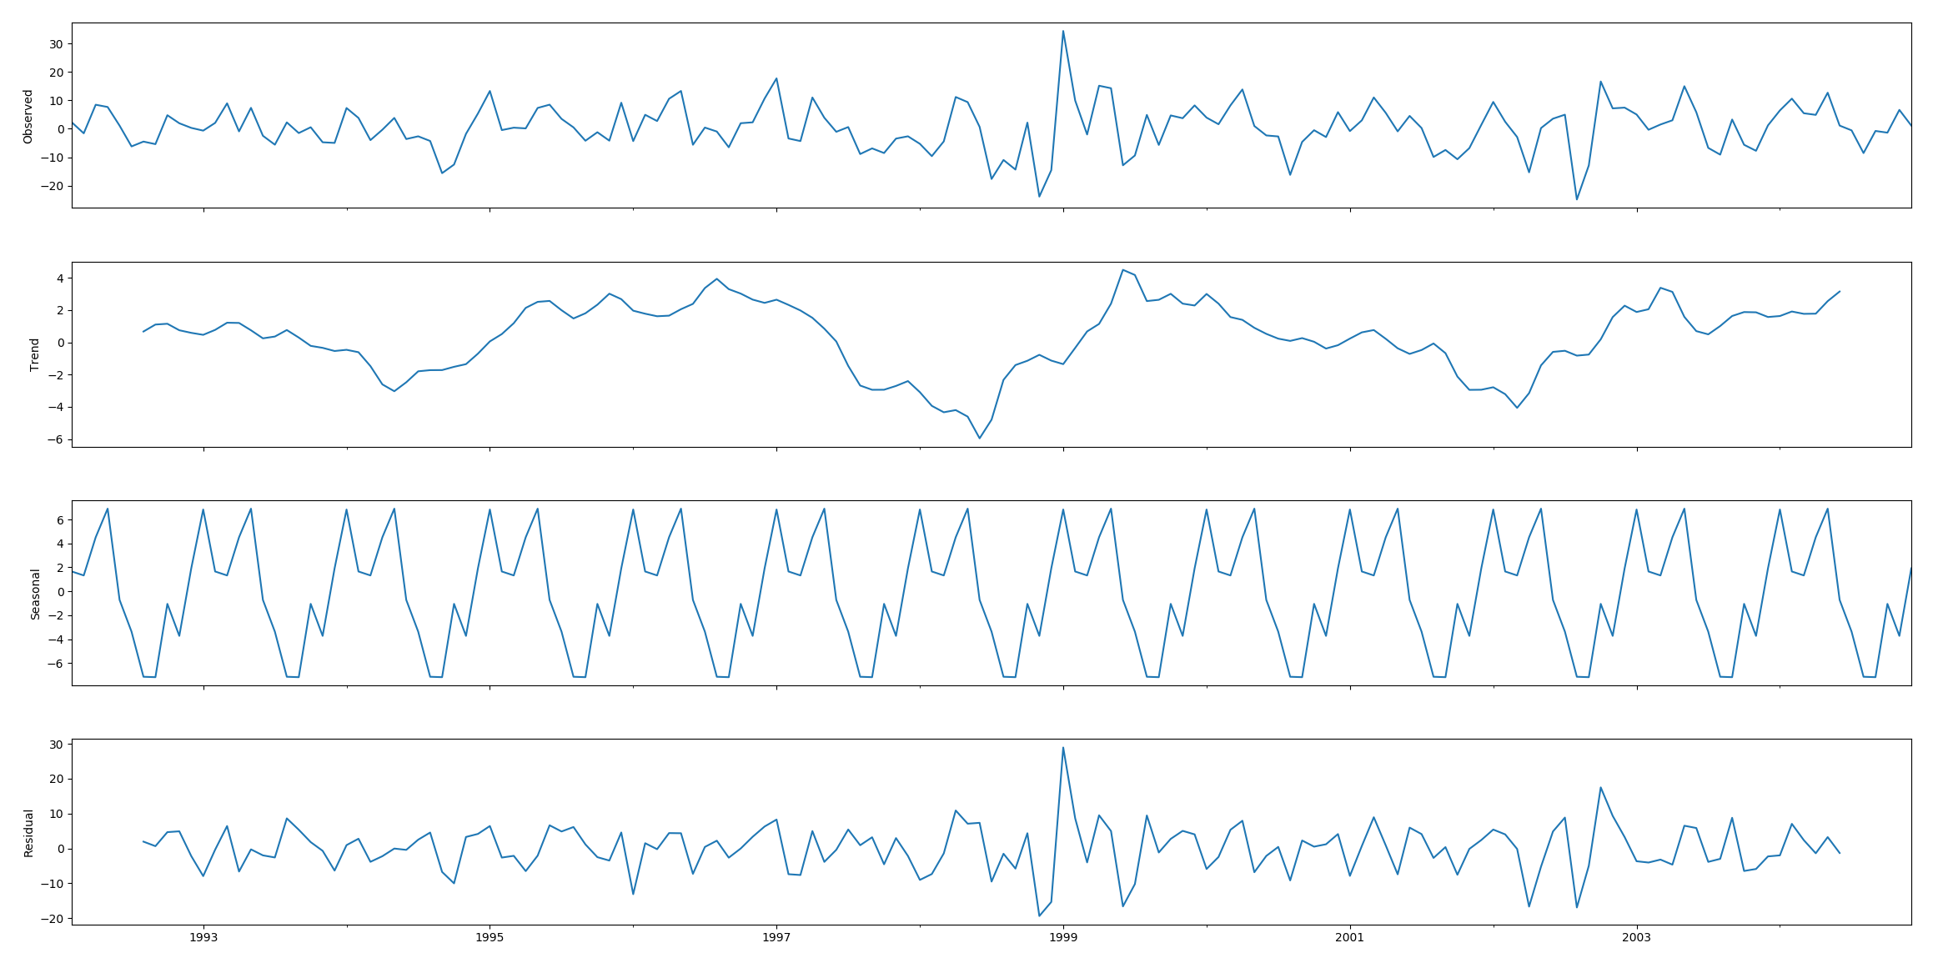

Figure 3-2. Lean hog future observed, trend, seasonal and residual

The left figure gives the ACF of log return of Lean Hogs Futures series. The spikes at lag 1 in the ACF and PACF exceed threshold that implies a MA(1) constitution, and the spike at lag 12 in the ACF implies a seasonal MA(1) part. The lags 12, 24, 36 in ACF plot are not decrease rapidly and they suggest a 12-period seasonal component. The right figure shows an exponential decay occurs in the seasonal lags of the PACF. Therefore, model is selected.

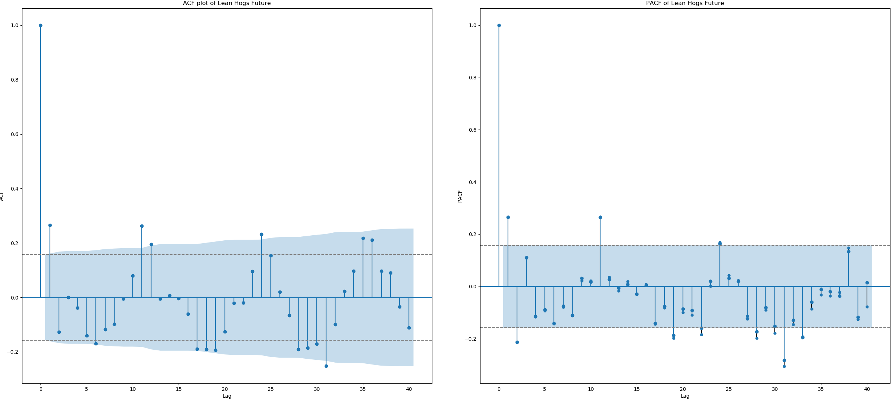

Figure 3-3. ACF and PACF of 100 times log return of Lean hog future

The fitted model coefficient and other information are displayed below.

Table 3-1. SARIMA Summary

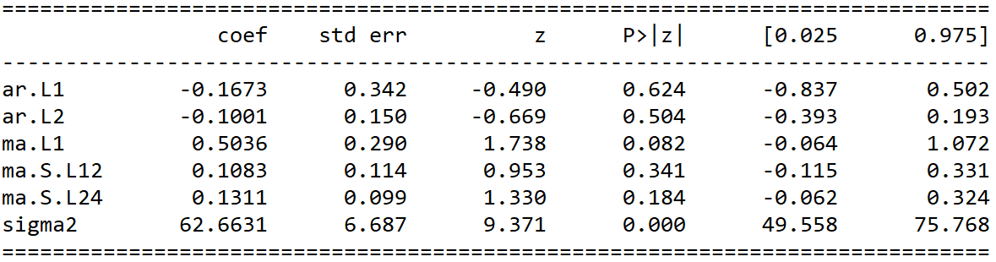

The residual of the model is stationary but has volatility clustering effect in sub-figure 1 in Figure 3-4. It means that lean hogs future may accommodate to GARCH model. The residual is conforming to Normal distribution but has heavy tails based upon the sub-figure 2 and sub-figure 3. ACF of residual shows no obvious autocorrelation effect. In third part, the article will test the GARCH model.

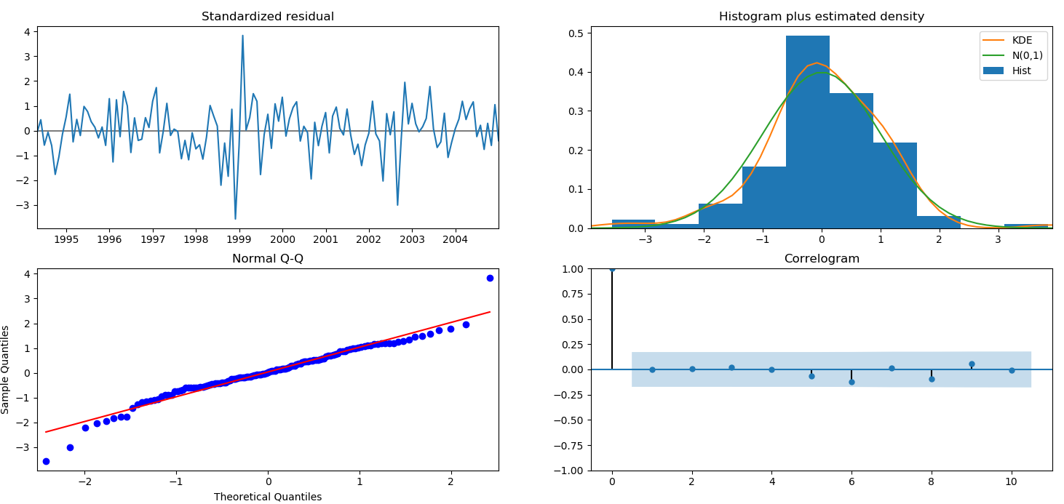

Figure 3-4. SARIMA Diagnosis

3.3 Predication and error

One step ahead forecast consists in comparing the true values with the forecast predictions. The training data set is from 1992 to 2003. The testing data set is from January 2004 to December 2004. The below figure shows that the data trend is well predicated. In seasonal ARIMA model, the mean squared error is 5.527.

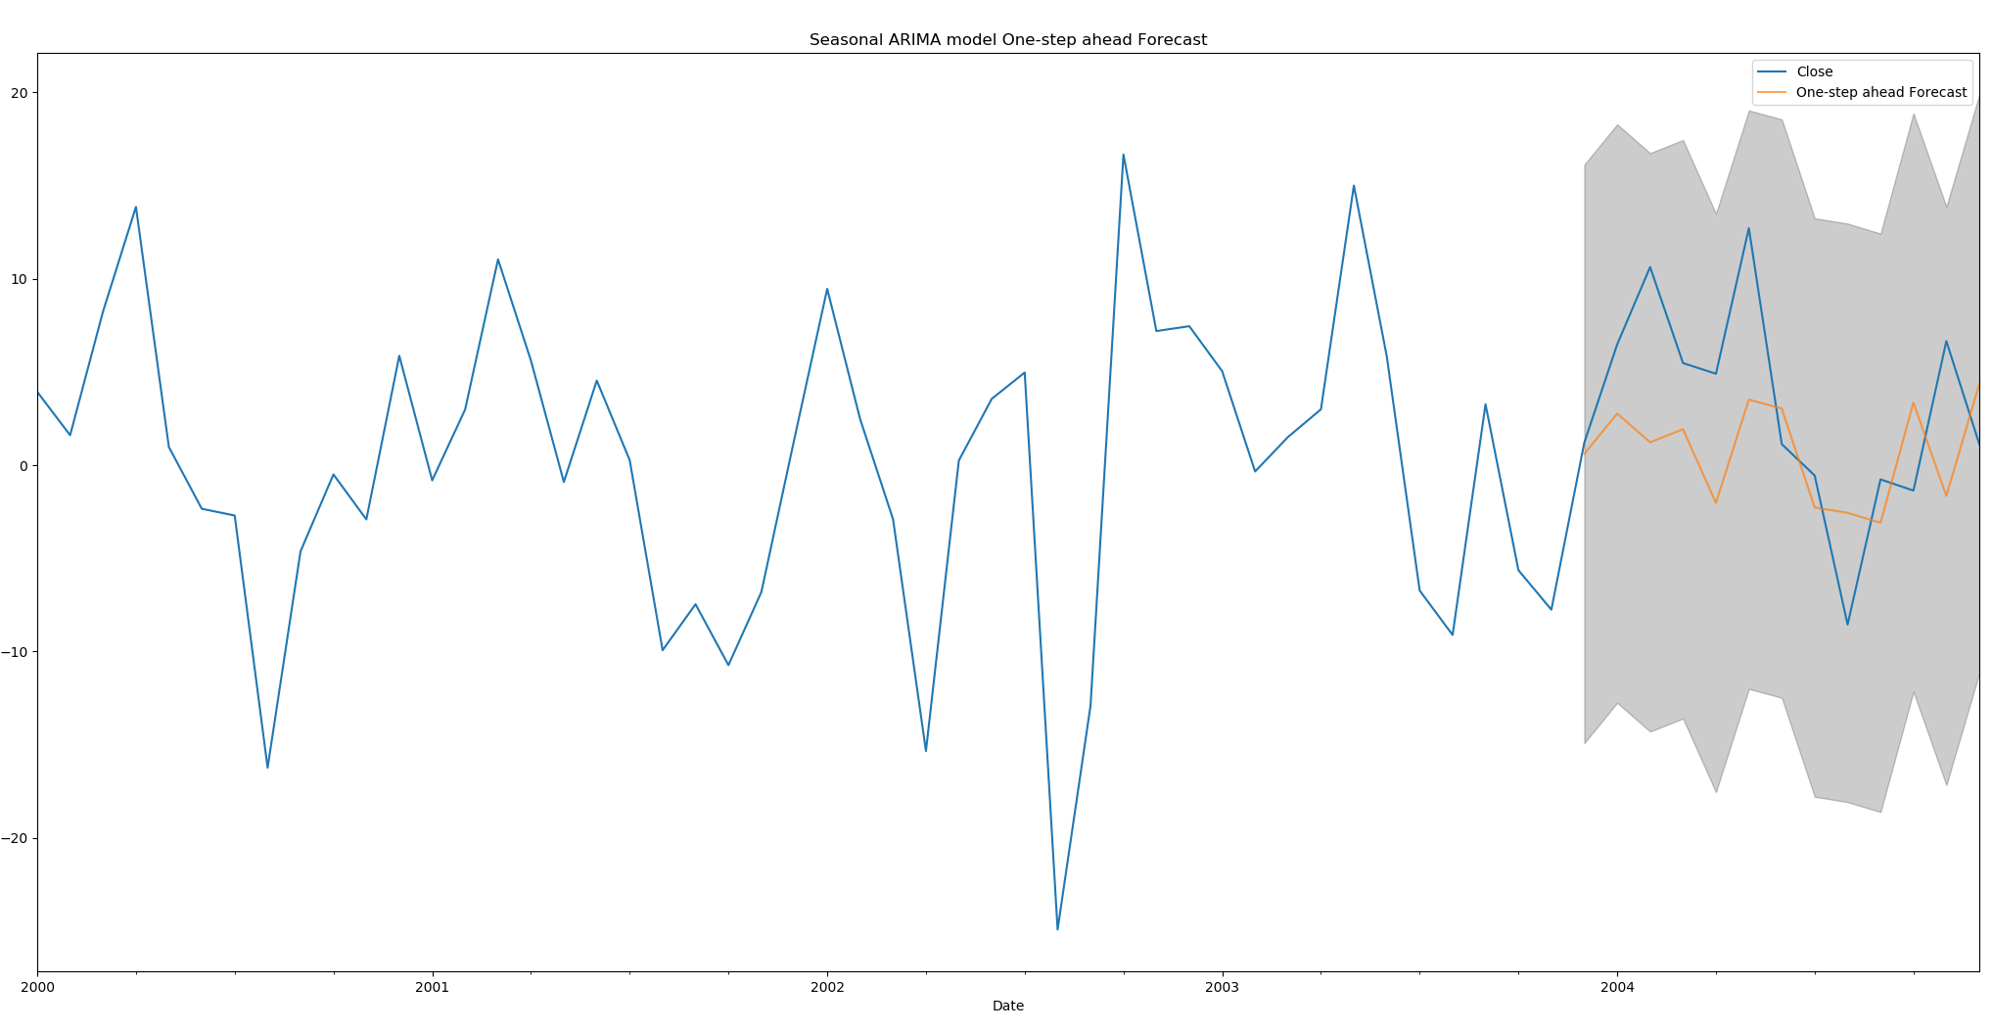

Figure 3-5. Seasonal ARIMA model one-step ahead forecast

3.4 Lessons

CME Lean hog future shows strong seasonality effect. If China market employs lean hog future, the lean hog future has high probability to contain seasonality effect. this part suggests that:

Pork is one of major meat consumed in China. The seasonality effect will bring huge influence on China market. The price starts to go high at the beginning of year. After the peak season, the price then goes down. It is best for Chinese investors to be careful about the seasonality effect in lean hog future. Investors can buy the futures when they are low and hedge the seasonal risk in advance.

Seasonal ARIMA model predicts a right trend of future return and has a good performance in predication. As a precautionary method, investors should use SARIMA or more advanced tools to predicate the fluctuation in case of market disorder. Accurate prediction models will help investors to predicate more correct results in the future. Investors should implement a well-organized plan to hedge the future risks and avoid predicated loss.

Market managers should react properly to the peak season prediction. If the model shows that the futures price is a pinnacle, it may imply the supply and demand equilibrium is not balanced. Market managers should arrange enough supply of pork to meet the demand from market so that demanders can buy enough meat at a low price. If the model shows that the future price is in a low area, it may indicate that the supply is more than demand. Market managers should decrease the market supply to sustain the pork price so that the pork can be lucrative to the suppliers. Market managers should establish market orders to prevent the arbitragers from disrupting the market. The arbitragers may deviate the market from normal level. When supply is less than demand, the price of future will increase. The arbitrage in the market will increase the price to abnormal level. Market managers should employ an efficient method to curb the price when price has momentum to become abnormal.

1. **GARCH Volatility Tests for lean hog future**

Financial time series usually display volatility clustering. When financial market meets the shock, the market entries the high volatility period and the market will become less stable compared to previous market. Like that the object has inertia in Physics, in financial market the volatilities also have inertia. The volatilities will have lead-lag effects on future volatilities. In 2019, China hogs market encountered the swine diseases, the market tended to become more and more volatile. The price of hogs became much higher than before.

In previous chapter, the paper exams the ARIMA model. However, ARIMA model does not show the correct volatility of the time series. ARMA models has a varied conditional expectation but a constant conditional variance. GARCH model is a better model to fit the nonconstant volatility of time series.

4.1 GARCH Model

GARCH model is derived from ARCH model. ARCH model’s full name is AutoRegressive Conditional Heteroscedasticity. The model is used to test the volatility of time series. In ARCH model, the conditional mean is a constant, but the volatility part changes according to its previous momentum. The ARCH model has similarity with AR model. The conditional standard deviation is the calculated by previous conditional standard deviations. In AR (1) model, the conditional standard deviation is calculated by lag 1 conditional standard deviation.

The formula of ARCH (p) can be written as below:

,

where

is the conditional standard deviation of calculated from the past values in the time series. is the white noise part and its distribution subjects to IID N(0,1). The unconditional mean of equals to zero. GARCH models allow the inclusion of past conditional variance so that the variance is consistent with past. The formula of GARCH(p, q) model can be shown as below:

,

Where

* 1. GARCH Model Test

In Part 3 SARIMA model test, we got the residue and residue square in Figure 4-1. There are substantial GARCH effects since the autocorrelations in the squared residuals are substantial and the Box Ljung test has an extremely small p value 3.458e-05. The PACF plot of residue shows that the spikes at lag 2 and lag 4 are obvious. The ACF plot in shows that no obvious spike before lag 10. Lag 11 has significant spike in ACF plot which can be ignored. Therefore, we will select GARCH(4,0), namely ARCH (4) model, to test the volatility clustering effects in CME lean hog future time series.

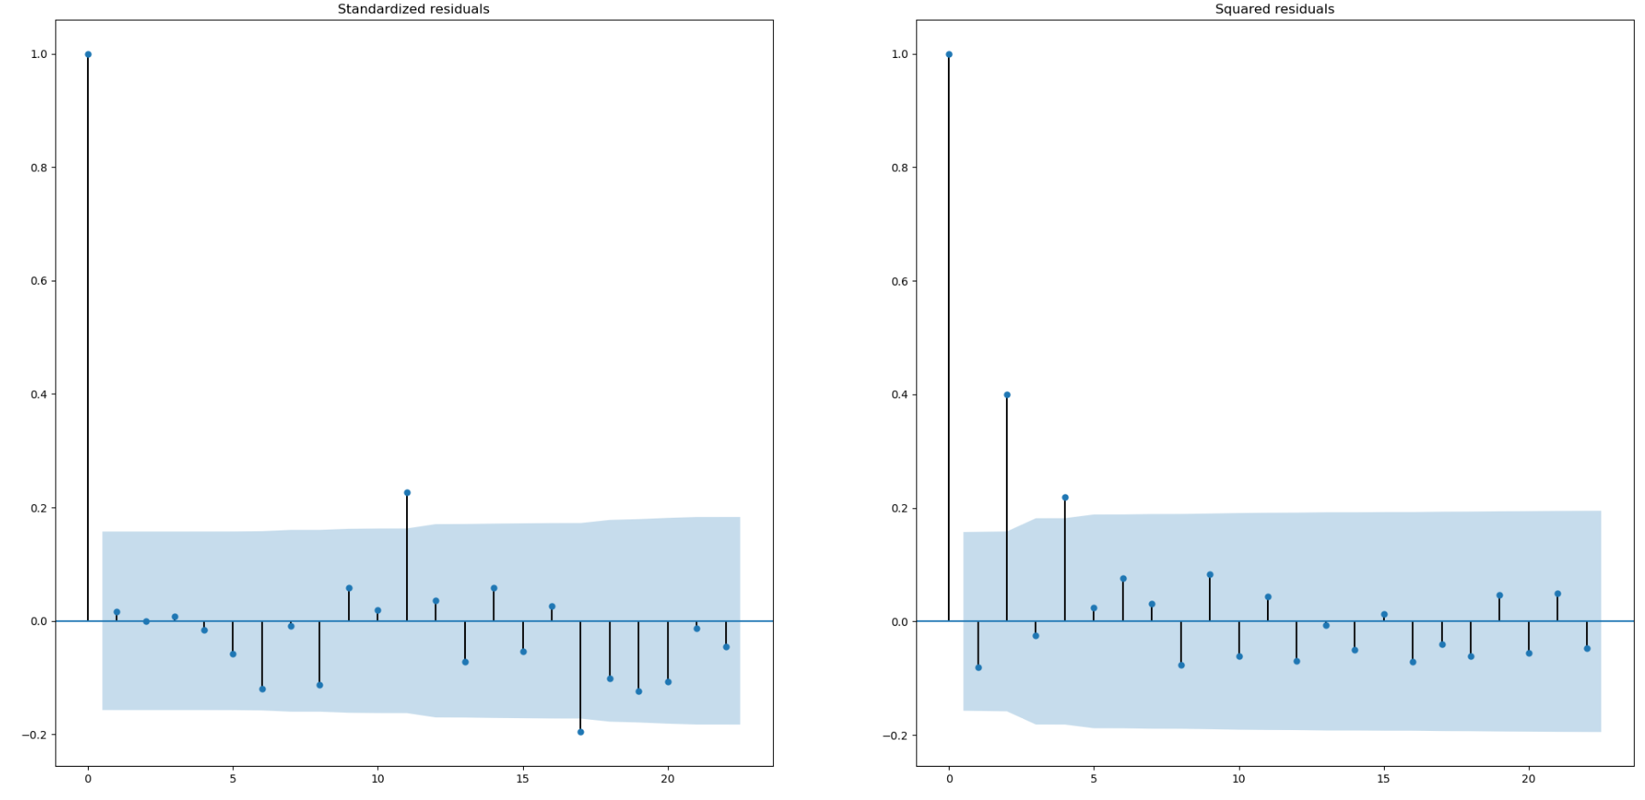

Figure 4-1. ACF of SARIMA residue and residue square

In Figure 4-2, CME lean hog futures’ prices in the past decades showing large fluctuations especially around the year 2014. with plenty vertical increases and decreases, the price changed swiftly, and the volatility is relatively high in this period. A clear evidence of significant serial auto-correlation in the original data can be found in auto-correlation plot. The shape of the QQ and Probability plots implies that the process subjects to normal distribution but has heavy tails.

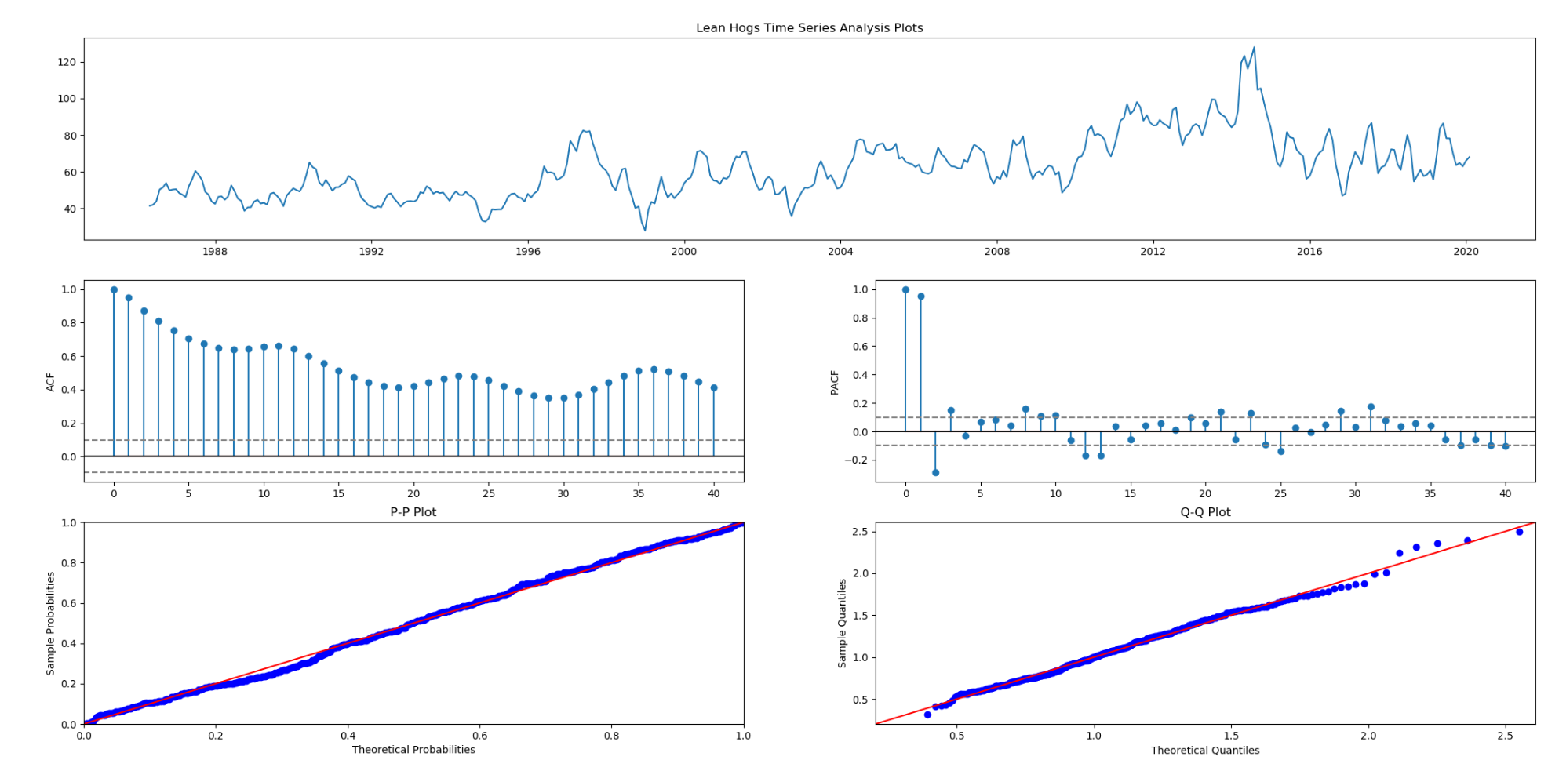

Figure 4-2. Lean hog future analysis

In Figure 4-3, the 100 times log return series plot shows periods of high and low variability. A process of random and centered about zero can be seen in the plot. The mean of monthly returns is next to zero. The monthly return has apparent volatility clustering, implying the existence of heteroscedasticity. The ACF is small, serially uncorrelated, but highly dependent. The shape of the QQ and Probability plots show the return has heavy tails and left skewness. Lean Hogs Future log return’s skewness is -0.0344 and Lean Hogs Future log return’s kurtosis is 1.2687.

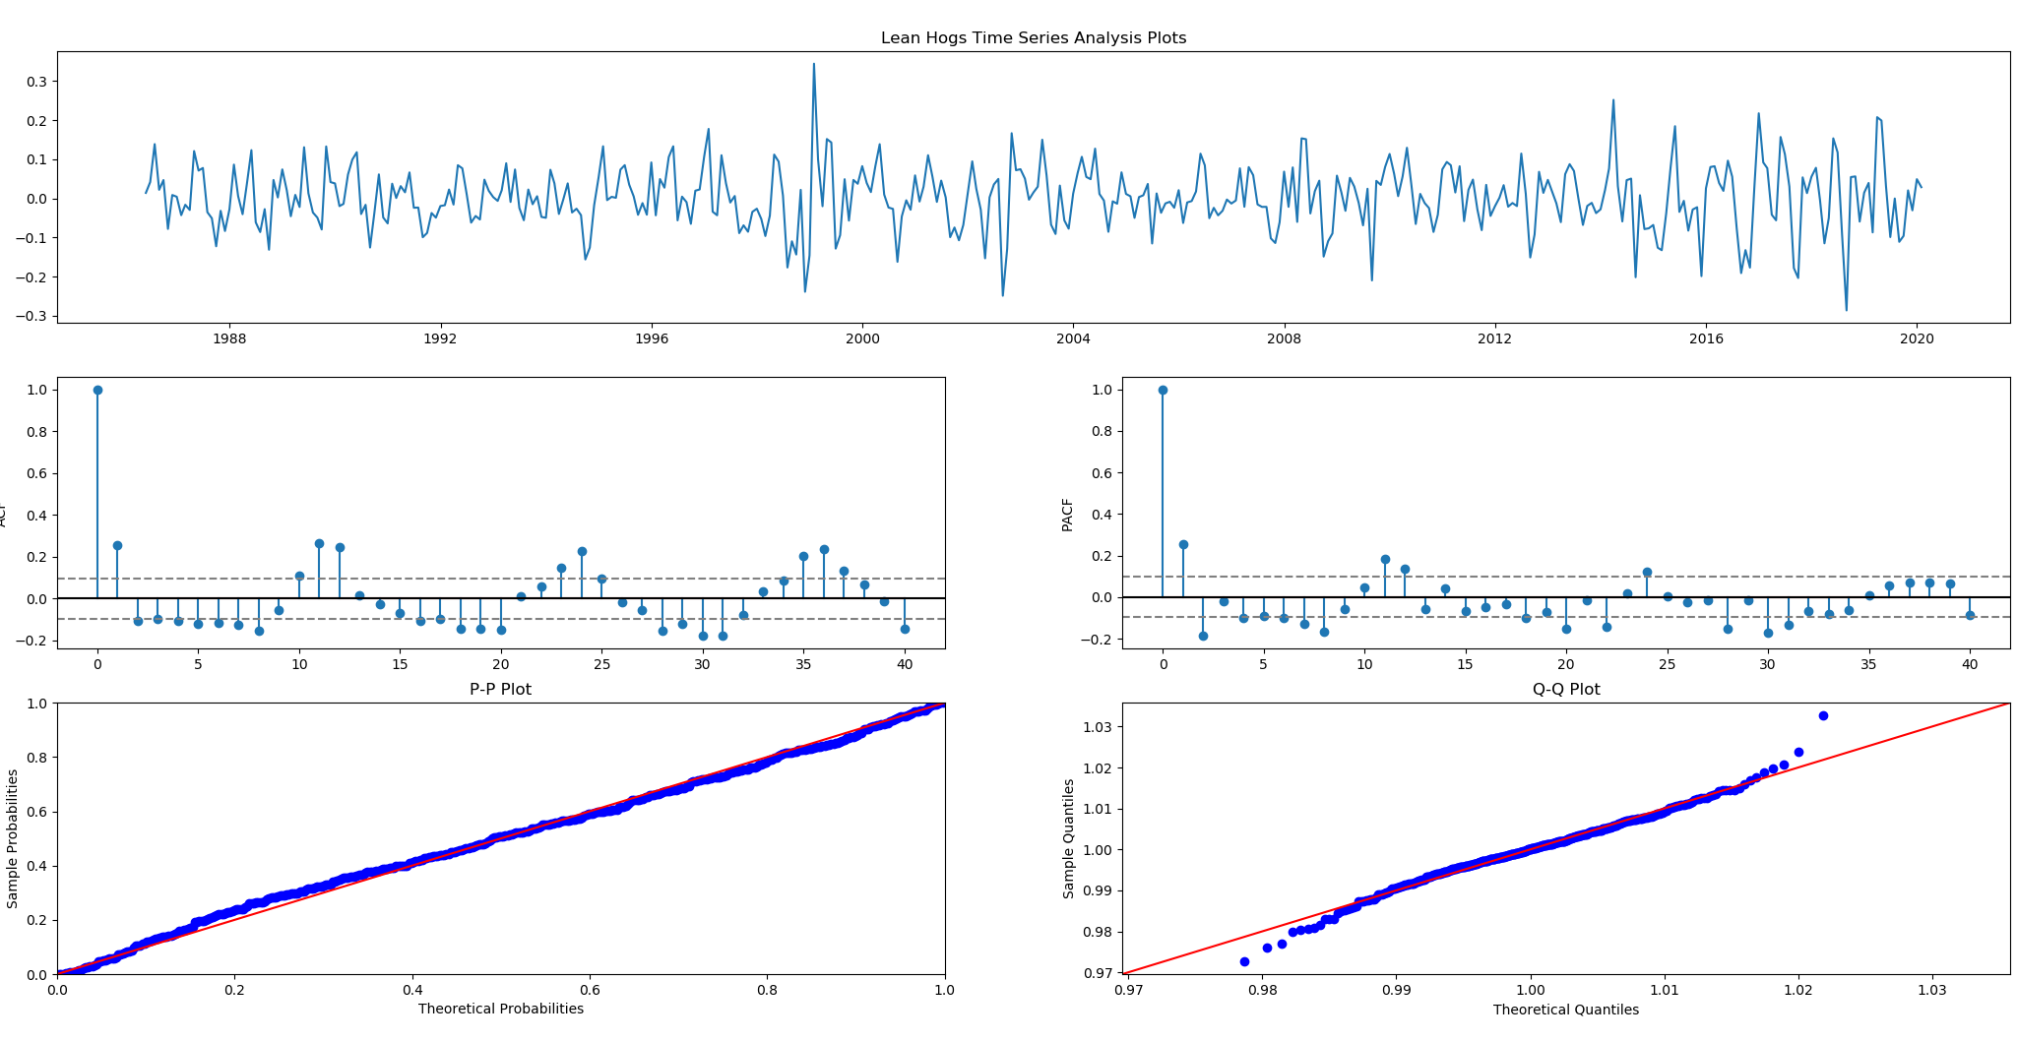

Figure 4-3. 100 times log return of lean hog future analysis

The tests shows that the GARCH(4,0) well fits model for lean hogs futures. After fitting our model, the model generates the standard residue’s ACF plot for reference. Apparently, the ACF plot shows that the autoregressive effect of square residue is offset by GARCH model. The model does show a perfect fit.

Table 4-1. GARCH model summary

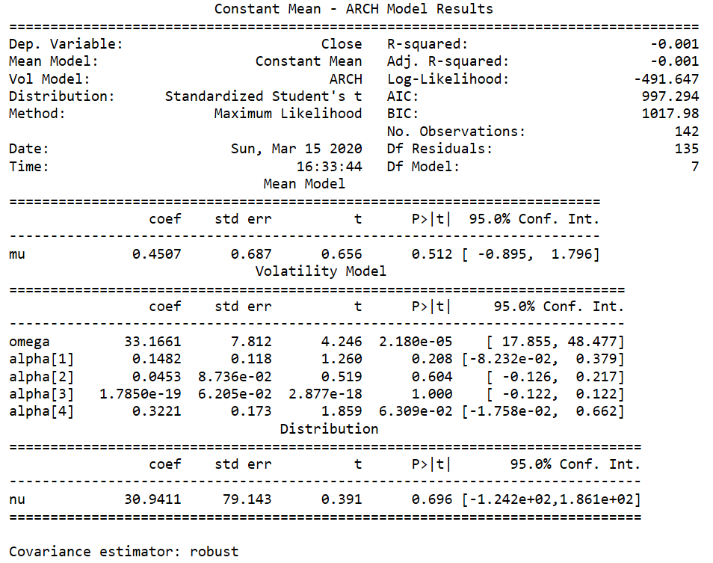

In the summary, since the sum of alpha[1], alpha[2], alpha[3] and alpha[4] is smaller than 1, the time series is stationary. The squared standardized error exhibits that the model fit the time series perfectly. no spike in ACF and PACF plots is out of the shaded confidence zone. Therefore, we regard the ARCH(4) model fitting the time series correctly.

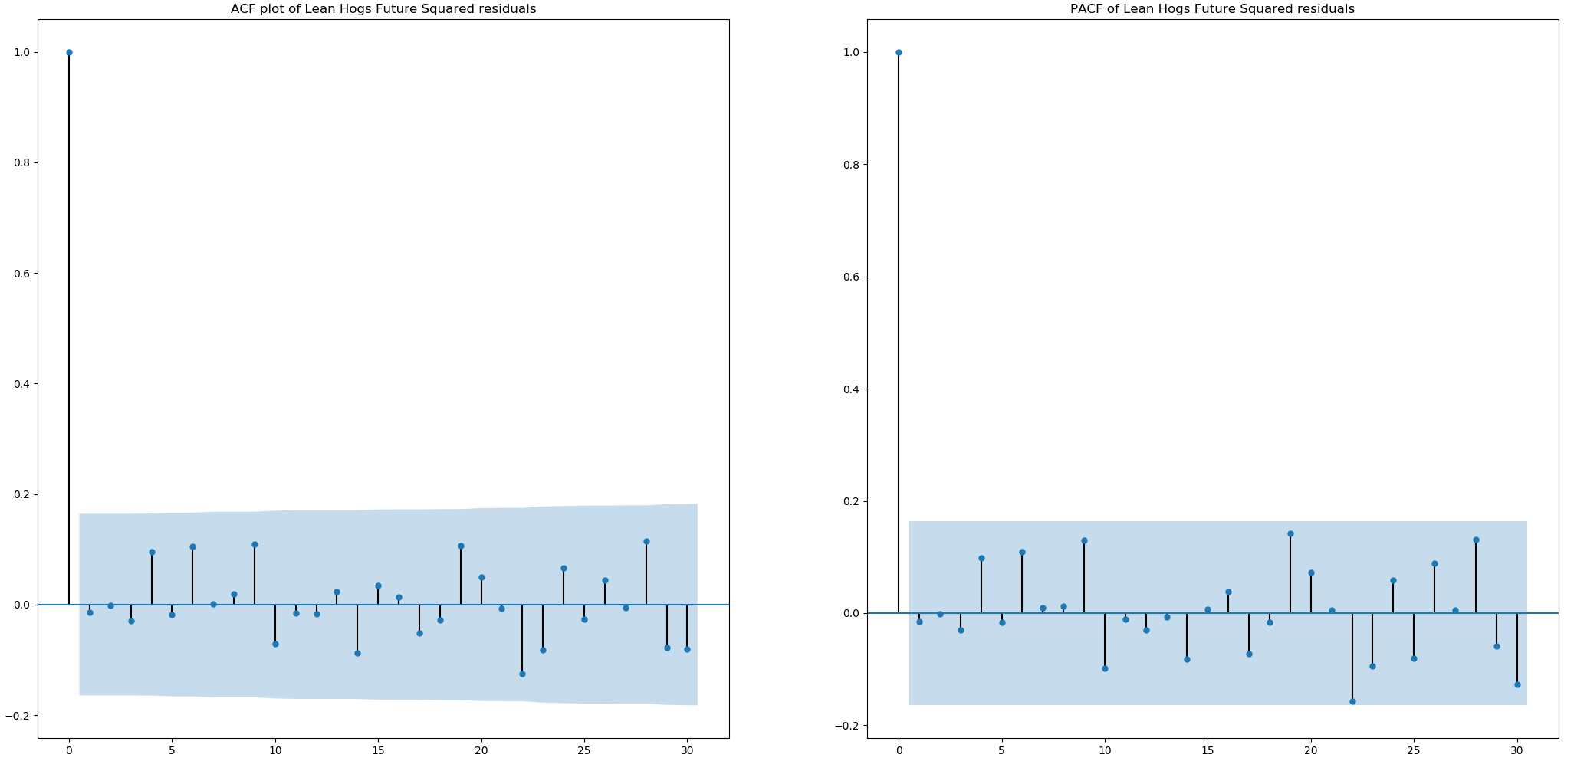

Figure 4-4. ACF and PACF of GARCH model squared standardized residual

4.3 The predication and error

After fitting the GARCH model, we use the GARCH model to predict the test data from Jan 2004 to Dec 2004. The prediction is shown in the figure 4-5. The mean square error between actual data and predicated data is 5.665.

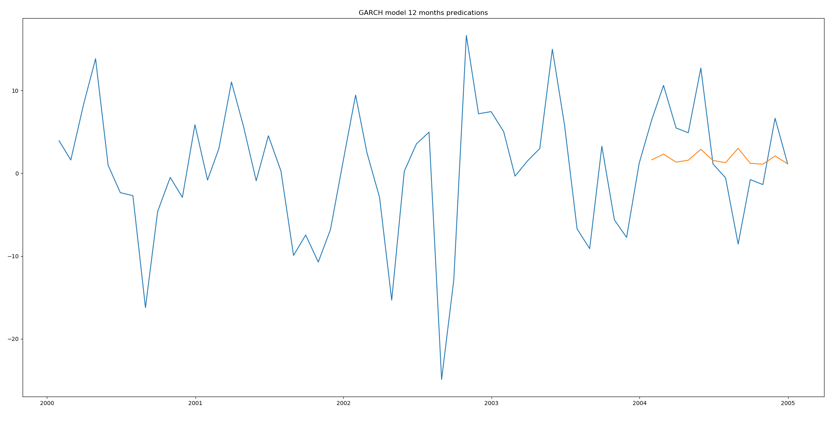

Figure 4-5. GARCH model predication

* 1. Lessons

CME Lean hog future shows strong volatility clustering effect. If China market employs lean hog future, the lean hog futures in China probably perform the same pattern as the lean hog futures in United states.

Since the CME lean hog future shows strong volatility clustering effect, it gives the market and market managers in China more challenges. When market become less stable, the market managers should recommend the market become rational. Do not overreact and become panic to the market. Otherwise, the market will become more unstable than before. In addition to being calm, the market managers should prohibit the arbitragers from entering the market. The arbitragers only take their profits and losses into considerations. They will manipulate the market to earn extra benefits from the unstable market. Their existence will disturb the market and drive the real investors out of market. Eventually, the market deviates from normal state and arbitragers earn huge profits when they decide to leave this market. The market managers should identify the real investors in the market. In order to operate the market healthy, the market managers can issue the certificates to real investors who participate in the hog industry. Thirdly, the market managers should issue more promotion policies to push the market become healthy In China. The market managers usually gave more tax cuts to the farmers and industries when they are required to help the market.

For investors, when they meet the fierce and abnormal market, they should stay calm and be rational. Fear can crash the market. The investors should regard the lean hog futures as the risk hedge tool to their real market. If they stay clam during the high volatility period, the market will regain the confidence and recover as a stable one. Secondly, investors should diversify their investment. Diversification will help investors diminish various risks stemmed from single asset. After mitigating the risks, the portfolio will become resistant during high volatility period. Thirdly, the circuit breaker mechanism will help market stay calm. When the market price drops a lot, the circuit breaker will be triggered, and the market will be halted for a while. After the investors calm down, the market will be restarted and continue to trade.

1. **VAR test for lean hog futures and other futures**

In the last two parts, the article focuses on the time series analysis of lean hog future. In the following parts, the article will concentrate on the correlation between different industries such as corn (pigs’ feeds) and cattle (pigs’ substitution). More characteristics will be unveiled by analyzing the correlation with corn and cattle.

Pigs cultivation need feeds. Hog producers feed pigs with corn and soybean meal in pigs’ industry. The pigs’ price is affected by feed. The price of corn should have an obvious correlation with the price of lean hog futures. Fred Gale (2017) indicated that China pig industry is less efficient than American pig industry in feed and pastures area. High feed price contributes to high pigs’ price. After pig grows mature and meet the requirement of market, the future of the lean hogs will become more expensive. However, some analysts believe that corn and pigs have a negative correlation when price fluctuates. An opposite opinion indicates that the price of corn may negatively affect the pork price. It is because that farmers have intentions to feed their hogs less corn if the price of corn surge. Since the hogs have not enough food, the hogs’ weight will not meet the requirement and the price of hog future will drop together. As an alternative to pork, beef price is another important reason for pork price fluctuation. In China, people will buy beef in place of pork when they feel the price of pork is out of their tolerance scope. This economic rule also applies to the meat consumption in United States. Beef and pork should enjoy an obvious negative correlation.

Our hypothesis is that the corn is positive related to pork’s price, but the beef is negative related to pork’s price. This part will examine this hypothesis. The data are from Bloomberg and they are lean hog futures, live cattle futures and corn futures. The ticker of live cattle futures and corn futures in Bloomberg are Generic 1st ‘LC’ Future and Generic 1st ‘C’ future. Based upon the analysis of part 1, the data time scope of live cattle futures and corn futures is also from 1992 to 2004. The test method is Vector Autoregressive model.

5.1 Vector Autoregressive Model introduction

A Vector autoregressive (VAR) model is useful to predict multiple time series variables. The VAR model is an extension of AR model. The VAR model of two time series can be written as below. Each time series is calculated based upon the past two time series. But the coefficients of two formula are different.

The s and s are the coefficient of VAR model. The VARs model and AR model share the same assumptions.

5.2 VAR model test

The first subplot in Figure 5-1 is the price of lean hog futures. The second is the price of corn futures. The third one is the price of live cattle futures. The Augmented Dickey-Fuller Results of three futures shows that the three futures are stationary.

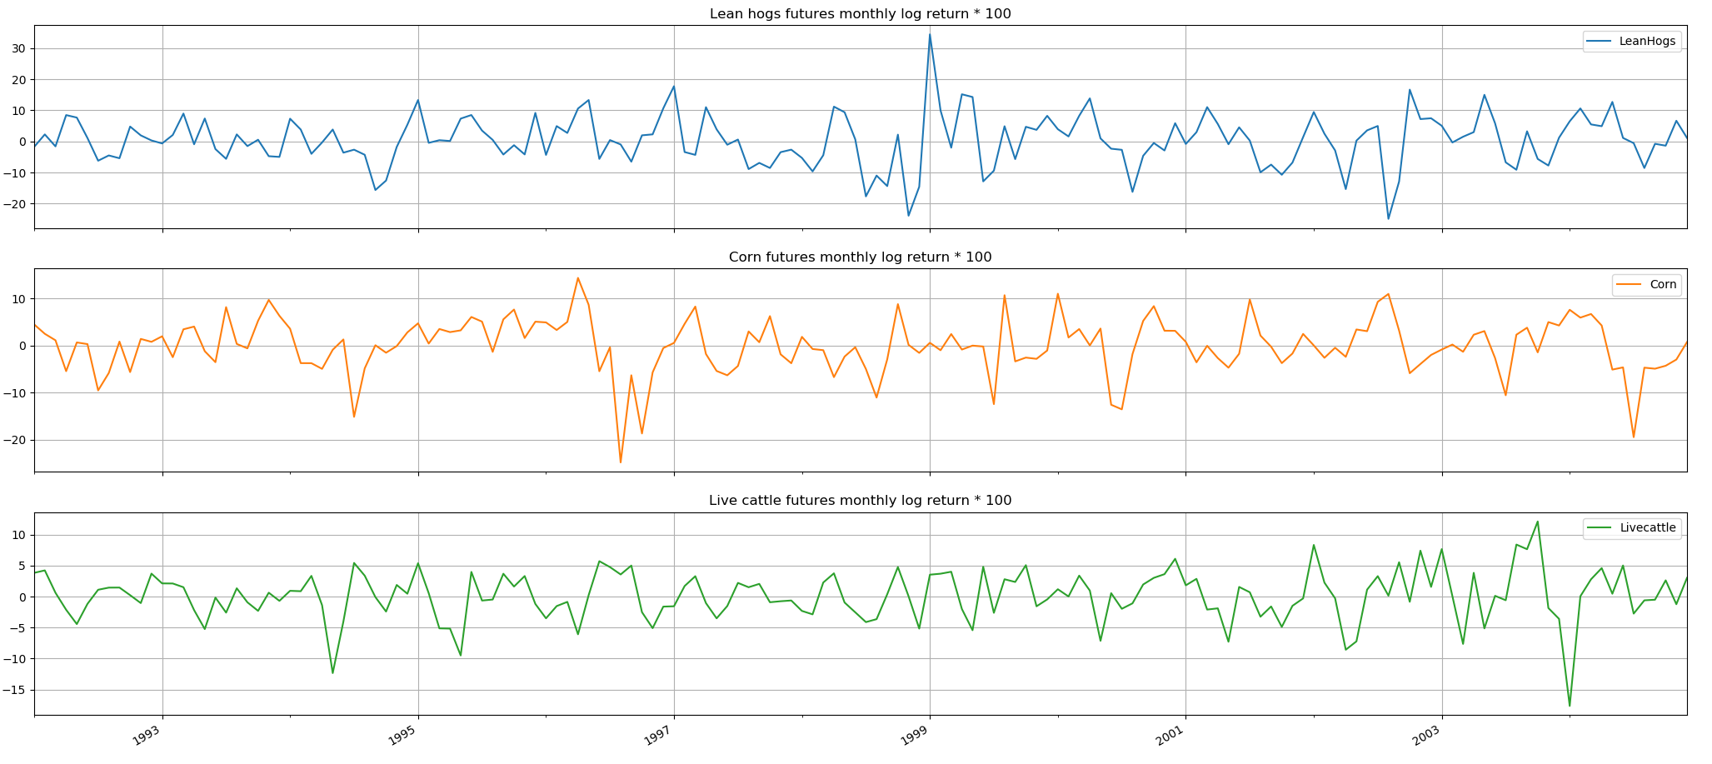

Figure 5-1. Lean hog future, corn future and live cattle future

The VAR (1) model is selected because its AIC criteria is the least among different models. The lean hog futures are negatively related to live cattle futures and positively related to corn futures. The coefficients of lean hog, corn and live cattle are 0.251, 0.0468 and -0.106, that means that the time series is stationary.

When hogs in US are delivered to next stage, the hogs’ weight must meet the required standards. No matter how much the corn price is, the hogs must be fed to certain weight. The price of hogs will increase if their feeds price increases. Our reasoning is also supported by the VAR tests since the coefficient of corn (0.0468) is positive. Therefore, we reject the hypothesis that the corn price will negatively affect the price of hogs.

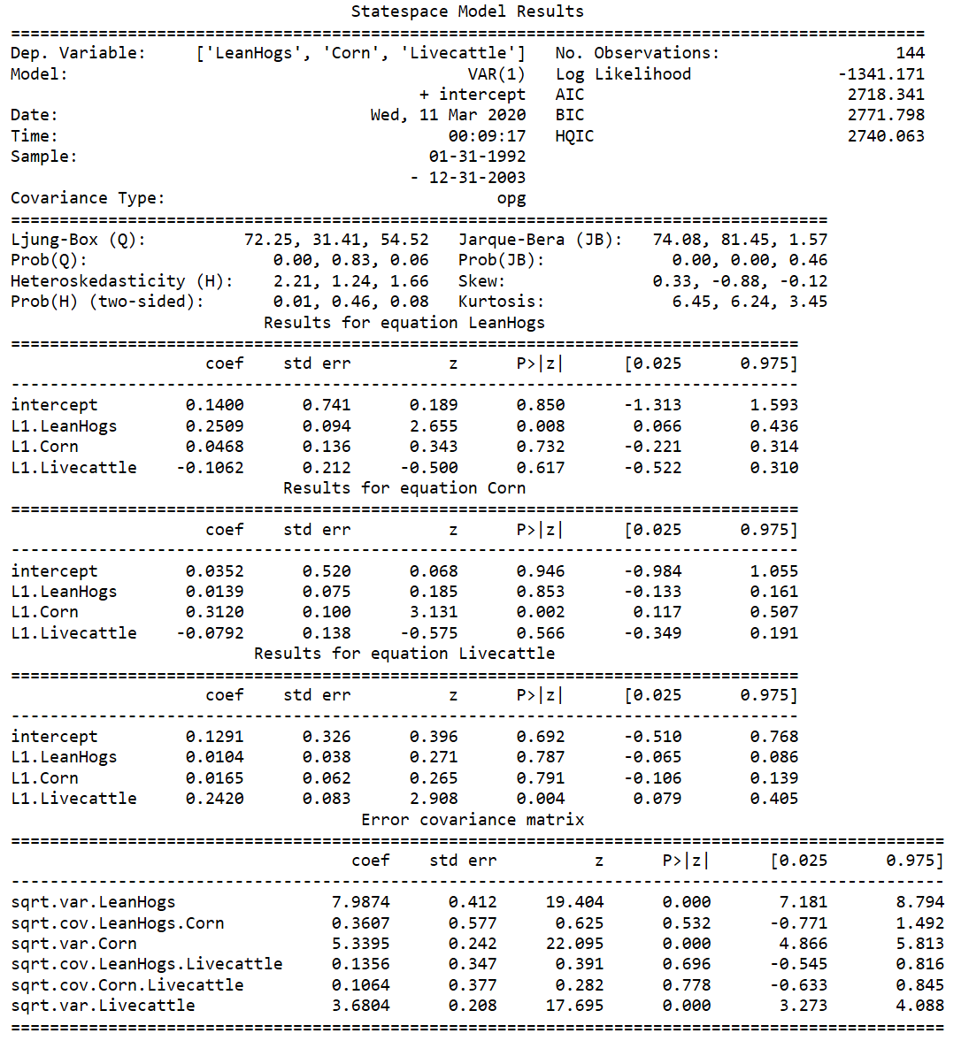

The VARMAX class in python is powerful and has plenty of usages. After model fitting, a common overall diagnostic is employed in below figure. The plot of the residuals obeys the model’s assumptions. The residuals conform the normal distribution, free of serial correlation. The model fit correctly.

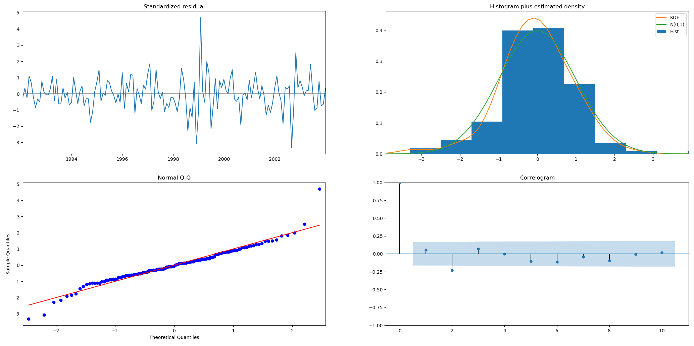

Figure 5-2 VAR model Diagnosis

5.3 Predications and error

We used the data from 1992 to 2003 to training the VAR model. The predication period is from Jan 2004 to Dec 2004. The predication is shown in below Figure 5-3. The mean squared error between predications and actuals 6.572.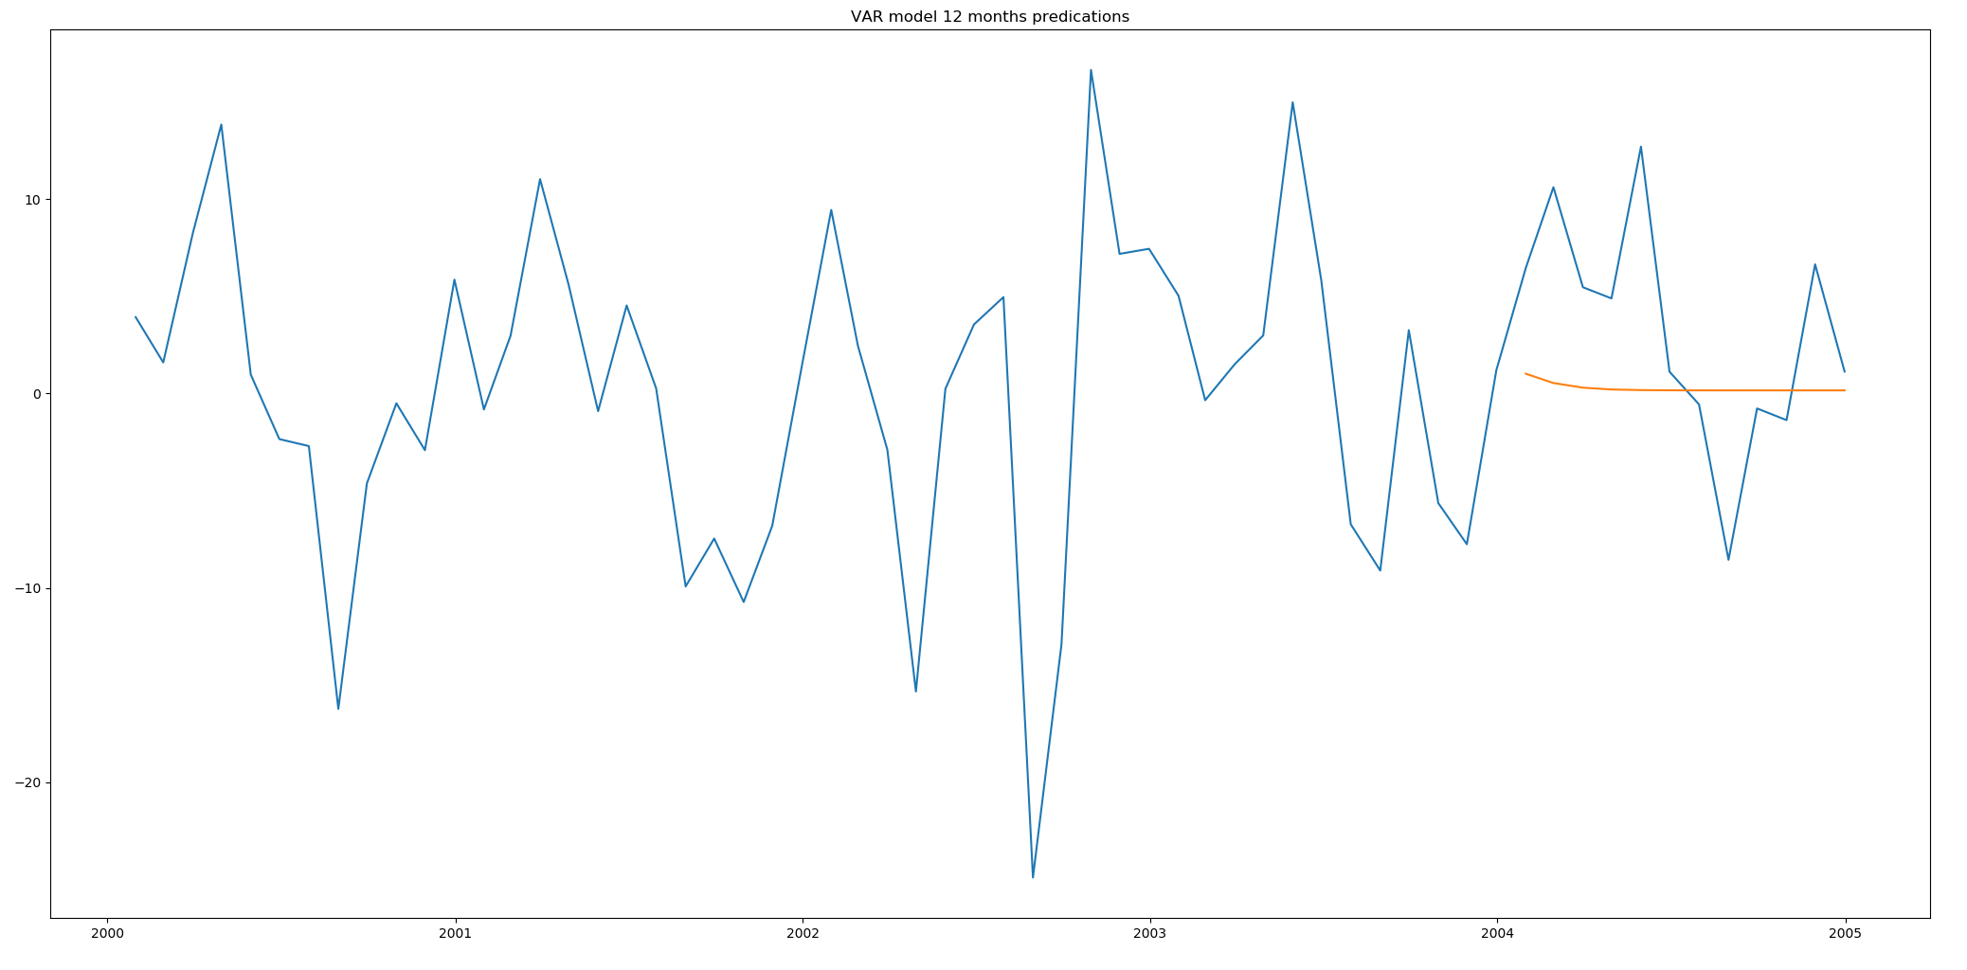

Figure 5-3. VAR model predications

5.4 Lesson:

CME Lean hog future has correlation with corn and live cattle futures. If China market employs lean hog future, it may have the same correlation with corn and live cattle futures.

The hog price is related to corn and beef. As the feed, the increasing corn price will cause the increase of hogs. On the contrary, the beef price increase, the lean hog price will be negatively affected. Market managers should maintain a stable supply of feed, such as corn and wheat. Stable supply of feed will help maintain stabilized price of pork. The supply of substitution of pork should also be well maintained. The unstable substitution price will deteriorate the stability of pork price.

Investors should be careful about the supply and price of feeder and substitution. Investors may buy the feed and substitutions futures or options to hedge the risks in pork.

1. Worldwide influence of lean hog futures

By now, the article only analyzes the lean hog futures of Chicago Mercantile Exchange and the relationship among lean hog futures, corn and cattle. Except for the analysis, the international relationship is also an important. The increasing globalization is an important factor to contribute world economy prosperity. Science and technology connect different parts of earth together and shorten the distance between countries. The multinational corporations are developing rapidly, especially the logistics company. The commodities movement between countries spends less time than before. International trade activities between countries and regions continue to increase. If Korea suffers from the supply shortage of pork, Korea can import pork from other countries like United States, Germany and China. If China encounters the similar circumstance, China can buy the hogs from other countries as well. So far, the exchanges that have carried out futures trading on the lean hog futures market mainly include the Chicago Mercantile Exchange, European Energy Exchange, and Korea Exchange. Martin Ziegelback and Gregor Kastner (2013) tested the relationship between US live hogs and Europe live hogs and found the arbitrage opportunity. According to our analysis mentioned above, the lean hog futures in three markets will have correlations and eventually they will share the same fluctuations in the global market.

Korean lean hog futures start from 2008. Bloomberg contains accurate but not sufficient data for test. Regarding Europe Energy Exchange Lean hog futures, Bloomberg provides scarce data. Based upon our data accuracy analysis, the data of Europe Energy Exchange lean hog future is not reliable. Therefore, we will not include the data from Europe Energy Exchange for further test. However South Korean data does not cover the period concluded in part 1. In order to find out the relationship among countries, the article will unleash the period constrains on data. The test method is ordinary least squares regression. The training period is from 2016 to 2019. The prediction test period is from Nov 2019 to Dec 2019.

Ordinary least squares (OLS) regression is a common statistical method to estimates the correlation between independent variables (X1, X2, X3, … , Xn) and one dependent variable (Y). The method will provide a linear formula to minimize the sum of the squares between the observed data and predicted values. The formula can be written as below:

Where is the coefficients of the linear formula, is the predicated value of dependent variable (Y). The OLS method will minimize the difference between Y and .

6.1 OLS test

This is the CME lean hog futures daily price and South Korea lean hogs futures daily price.

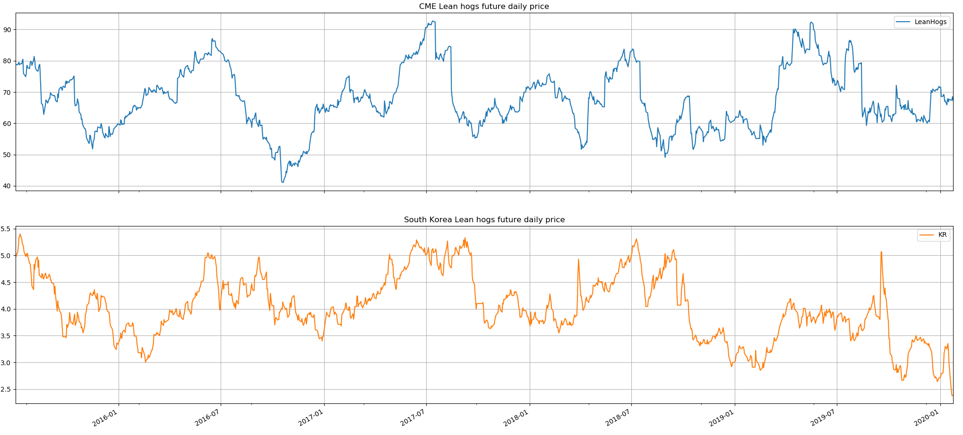

Figure 6-1. CME lean hog future and South Korea lean hog future

This is the 100 times CME lean hog futures monthly log return and 100 times South Korea lean hogs futures monthly log return.

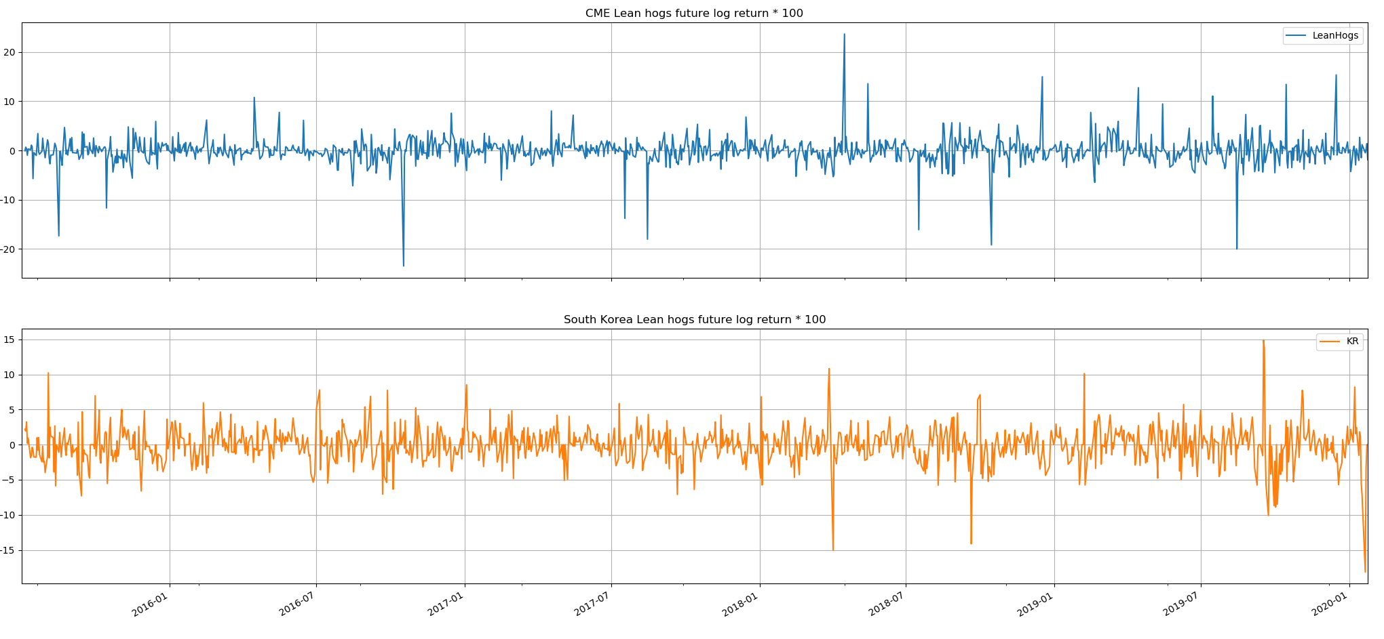

Figure 6-2. 100 times log return of CME lean hog future and South Korea lean hog future

The OLS regression results show that the coefficient of variable is 0.0518 (Positive). CME lean hog future is positively correlated with South Korea lean hogs future.

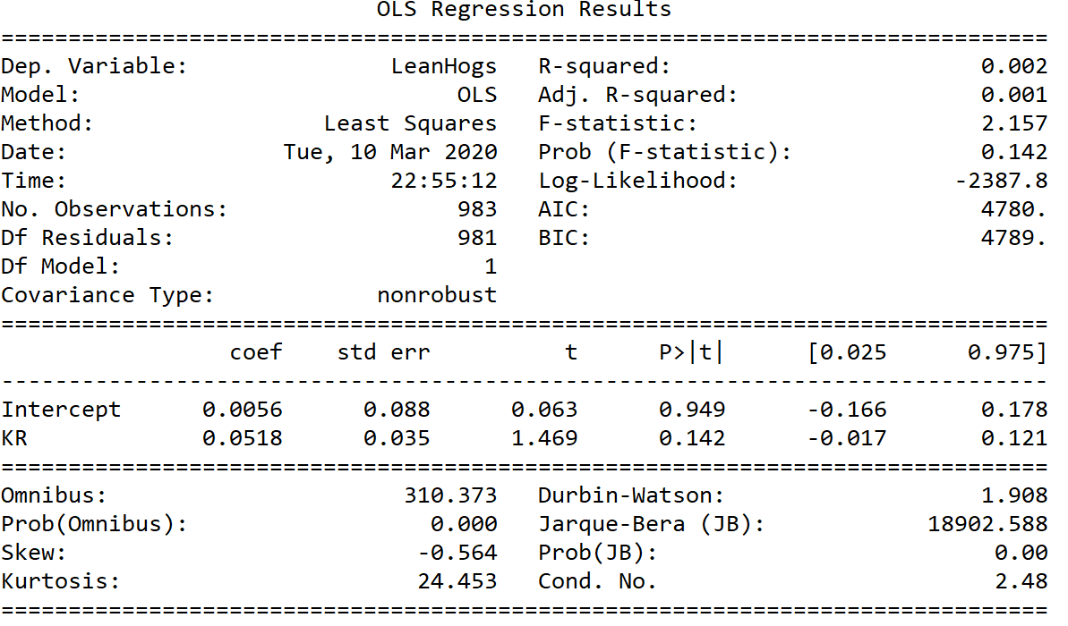

The simulate plot is below shows that the correlation between CME lean hogs future and South Korea lean hogs futures is not strong.

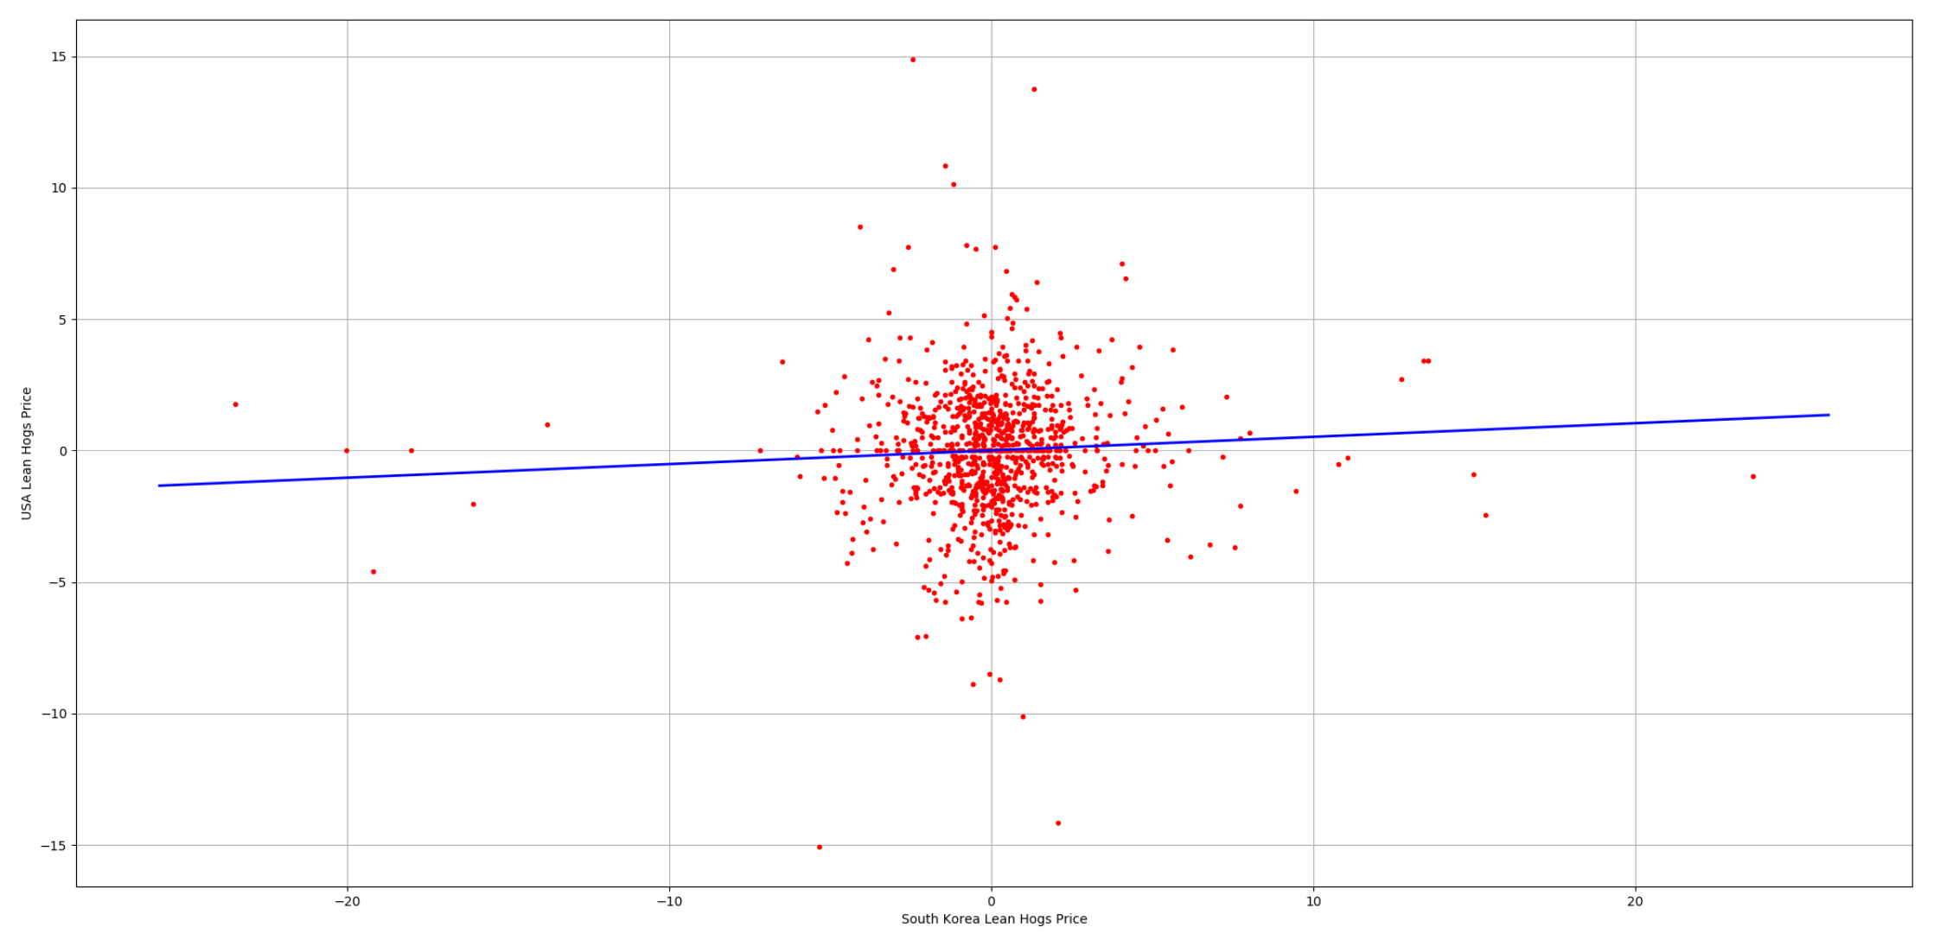

Figure 6-3. OLS result of CME lean hog future and South Korea lean hog future

6.2 OLS predications and error

We use the fitted OLS model and 30 days data of South Korea Lean hog future to predicate the 30 days results for CME lean hogs future. The Mean Squared Error between actual data and predicated data is 9.65 and the Root Mean Squared Error is 3.11.

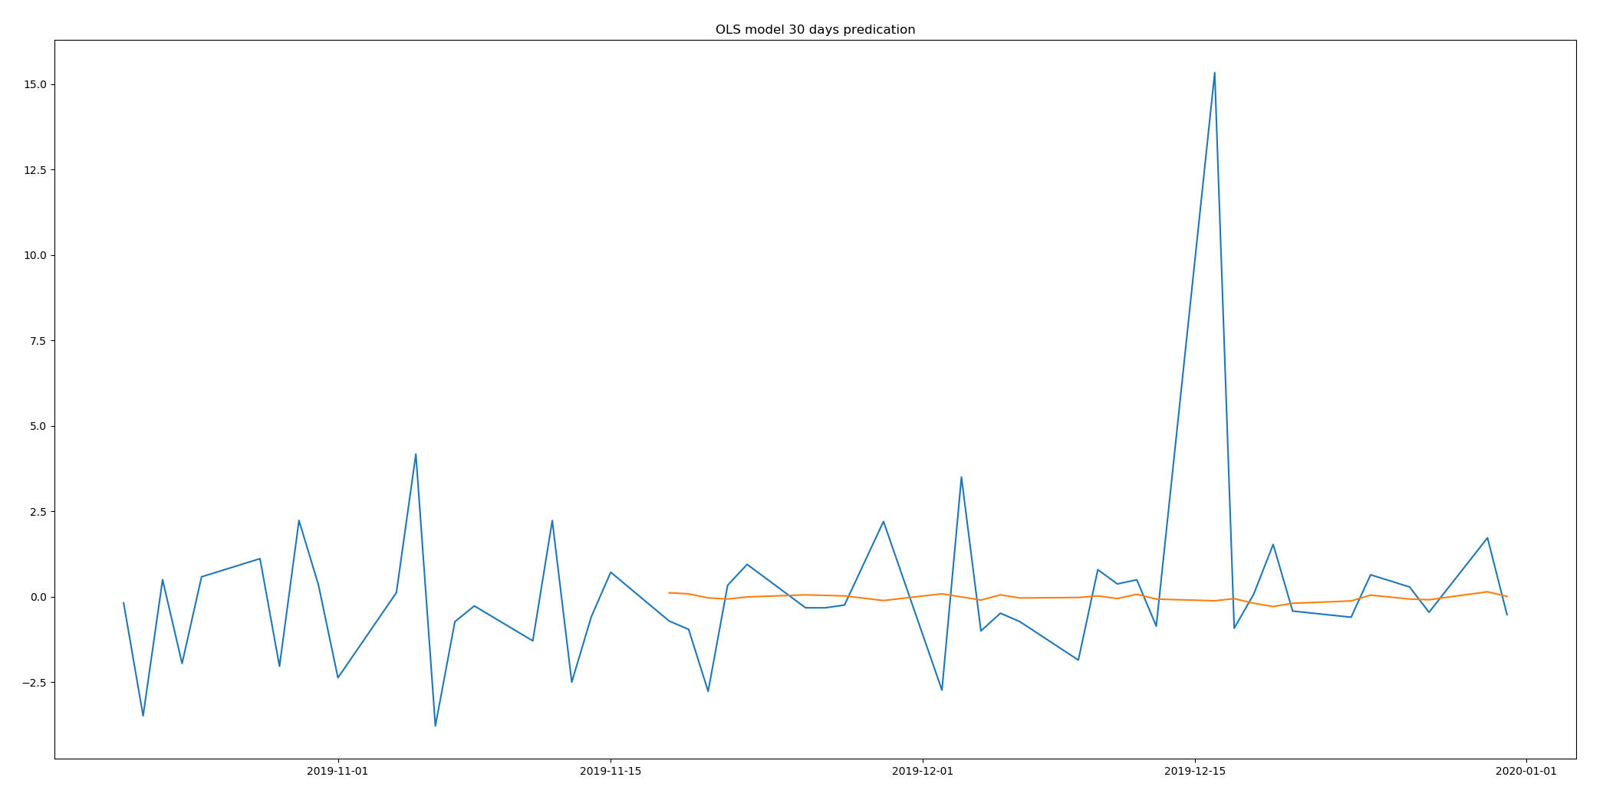

Figure 6-4. OLS model predications

6.3 Lesson:

CME Lean hog future has correlation with global lean hog futures. If China market employs lean hog future, it may subject to global lean hog futures’ influence:

Investors should be aware of the fluctuations from foreign countries. When supply in foreign countries goes low, the supply in China will be affected as well. At this time, if the demand increases, the price of hogs will surge. Therefore, when they meet this circumstance, they should have an eye on the global market and prepare in advance to stop the market disruption.

The market managers should schedule a reasonable export and import policy to make sure that China market has enough supply. When the domestic supply exceeds the domestic demand, the market managers should encourage the pork export and stabilize the supply price to protect the proactive of suppliers. However, if the domestic demand supersedes the domestic supply, the market managers should increase import from foreign market to decrease the pork price to protect consumers.

The market mangers should maintain the pork reserve. If the global supply shortage of pork occurs, the country will have no source for pork import. In such case, the pork reserve will decelerate the deterioration from global pork market and accelerate the recovery of domestic market. For example, when citizens notice the supply shortage in the global market, they will worry about the local market as well. In this scenario, the panic buying will happen in the market. If the market managers announce that they contain sufficient reserve and domestic supply, the domestic market will turn to be rational. This scenario happens in Singapore when the market has not enough surgical masks supply.

1. Conclusion

In this article, we employ four different models to predict the lean hog future price. Based upon the mean square error, the SARIMA model predicates more accurate data compared with other three methods. These four models have their own defects. SARIMA model does not consider the Volatility clustering effect. The GARCH model does not have ARIMA part. The VAR model does not consider the GARCH effect as well. The OLS does not explain many data in the test since the R square rate is low.

Table 7-1. Comparison of four models

|  |  |  |  |  |
| --- | --- | --- | --- | --- |
| Model | SARIMA | GARCH | VAR | OLS |
| Factors | CME hogs | CME hogs | CME Hogs, corn and cattle | CME hogs and South Korea hogs |
| MSE | 5.53 | 5.665 | 6.57 | 9.65 |
| shortcomings | Do not consider GARCH effect | Do not have ARIMA component | Do not consider GARCH effect | Linear model |

This article demonstrates some characteristics of CME lean hog future. The CME lean hog future has seasonal autoregressive effect. That means the lean hog future price has regular periodic fluctuations. The future price contains the volatility clustering effects. The price will tend to be more volatile when the price become unstable. Thirdly, the CME lean hog future has correlation with corn and live cattle futures. The corn price positively changes with lean hog future. But live cattle future negatively fluctuates with lean hog future. Fourth, CME lean hog future is influenced by South Korean market, which exhibits that the lean hog may have global effect. It is common and reasonable since the logistics rapid develops and global market is integrated together. When China decides to employ lean hog future in the thirteen five-year plan, these characteristics may still be valid. Our research is designed upon current China pork industry. The market is similar to United States Pork industry from 1992 to 2004.

During swine disease period, new technologies may exhibit their advantages in hog industry and accelerate hog industry transformation and upgrade. In 2018, China leading e-commerce company JD announced that they will integrate Artificial intelligence, block chain and Internet of things technologies into hog industry. In the plant, every pig will have its own face ID. The company receives the daily record of each pigs’ exercise and feeding and understand what pigs prefer to eat and what they do not like to eat. The block chain will record the species, birthdate, ancestors, descendants and logistics. The internet of things provides a cozy place to live. The plant turns to be clean, hygiene, and full of fresh air, at the most appropriate humidity and temperature. In this environment, pigs will grow faster and bigger. The pork meat will have higher quality and better taste. Before JD, China internet company NetEase have joined in hog industry for years. The pork price from the NetEase is high and the quality is better in comparison with traditional farm. Now the NetEase pork is a well-know trademark. Traditional farm transformation and upgrade need more efforts from advanced technology companies. With the help from different industries, the traditional hog industry will become prosperous and thriving.

Honestly, it is very difficult to start the lean hog future from scratch. The first obstacle is that the future contracts is very hard to standardize. The difference in pig breeds and quality is quite large because the limitations of producing in different areas of China. Unlike the hog industry in USA, the main production area mainly located in Iowa and Maine. These differences bring difficulty to the setting of the delivery grade in the contract design. The second reason is the delivery problems. As a livestock and fresh agricultural product futures, hog futures are different from the traditional storage-resistant futures varieties. In the process of physical delivery, there are often more operational obstacles and risks. For example, the storage problem of live pigs during live transportation, and the more difficult risk of pig epidemic transmission. When the lean hog future listed in US, the delivery method was physical delivery. From 1992, the contract become prevalent, and the delivery method had become cash settlement. In fact, these obstacles exist more or less in other countries, but they have not affected the United States, Germany and South Korea to eventually launch pig futures. As we can see, USA has run the lean hog future for more than 30 years and this future still plays an important role in American agriculture producing now. Since we have experience from other countries, we can employ this future better.

1. Reference

China Ministry of Agriculture. 2017. Quan Guo Sheng Zhu Fazhan Guihua (2016-2020) [National Hog Production Development Plan 2016-2020].

Fang, C., F. Fuller, M. Lopez, and F. Tuan. 2000. “Livestock Production Slowly Evolving From Sideline to Principal Occupation,” in H.-H. Hsu and M. Lopez, China: Situation and Outlook Series, International Agriculture and Trade Reports, WRS-99-4. <https://www.ers.usda.gov/>webdocs/publications/wrs994/54066_wrs99-4.pdf (accessed December 2016).

Fred Gale. 2017. “China’s Pork Imports Rise Along with Production Costs”, USDA Economic Research Service.

Isengildina, O., Irwin, S. H. and Good, D. L. (2004). Evaluation of USDA interval forecasts of corn and soybean prices. American Journal of Agricultural Economics 86(4): 990–1004.

Martin Ziegelback, Gregor Kastner. (2013). Arbitrage hedging in markets for the US lean hogs and the EU live pigs. Agricultural Economics (AGRICECON) 59(11):505-511.

Wang, Z., Fausti, S. W. and Qasmi, B. A. (2012). Variance risk premiums and predictive power of alternative forward variances in the corn market. Journal of Futures Markets 32(6): 587–608.

William D Mcbride and Nigel Key (2013). U.S. Hog Production From 1992 to 2009: Technology, Restructuring, and Productivity Growth. Economic Research Report No. (ERR-158) 48 pp.

Schulz, L. 2019, "Lean hog futures overly positive", Corn & Soybean Digest (Online Exclusive) .

1. Source: Livestock and poultry slaughter (1000 heads), USDA Economic Research Service